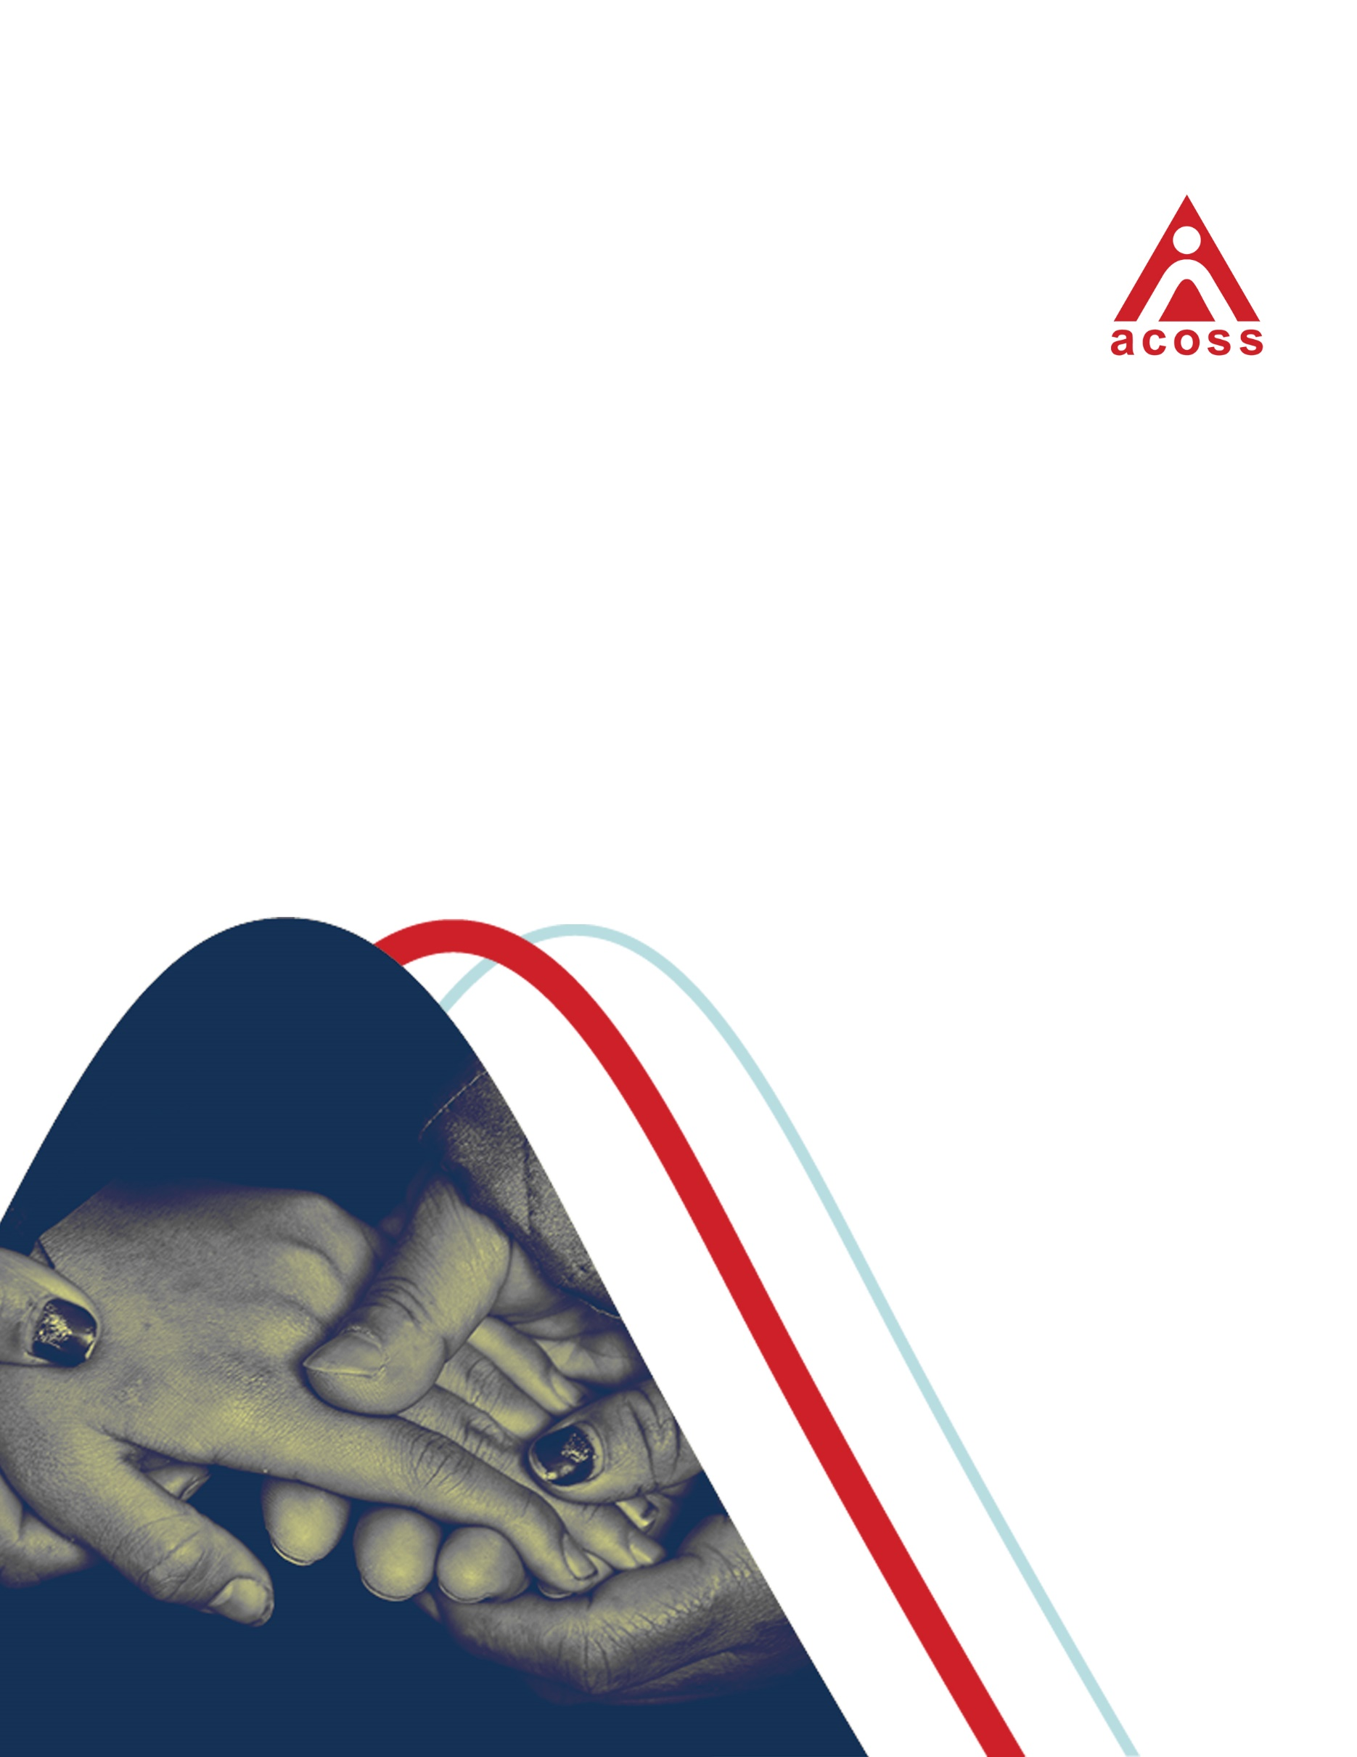Submission to the Fair Work Commission

on the minimum wage

March 2020

# 

# Contents Page

Summary 3

Recent economic and labour market trends 7

Living standards 9

Relationship between minimum wages and social security 11

Employment 14

Recommendations 15

# Summary

ACOSS welcomes the opportunity to make this submission to the 2019-20 Annual Wage Review. ACOSS is an interested party in these proceedings with expertise in poverty, employment policy and income support policy. Our long-standing interest in minimum wages stems from their impact on poverty and inequality in Australia.

The National Minimum Wage (NMW) is currently $741 per week, $19.49 per hour, or around $38,500 per year. Last year’s minimum wage increase determined by the Fair Work Commission was 3% ($21.60 per week).[1]

The NMW has only increased in real terms by an average of 0.7% per annum over the last decade as wages for people on higher incomes have risen more strongly. Over the long-term, the NMW has fallen when compared with the median fulltime wage (from 61% of fulltime median weekly earnings in 1996 to 51% in 2018), leaving minimum wage-earners and their families falling behind improvements in community living standards.[2]

Minimum wage levels affect poverty and inequality in at least three ways:

* through their direct effect on the disposable incomes of low paid workers and their families;
* through their indirect effect on social security payments;
* through their effect on employment.

Minimum wage rates, along with the tax-transfer system, have a direct impact on poverty.

The forthcoming ACOSS/UNSW report, ‘Poverty in Australia 2020’ includes estimates of poverty among people in households where wages were the main source of income, derived from the ABS 2017-18 Survey of Income and Wealth. [3]

We find that in 2017-18, there were 1,017,000 people living below the 50% of median income poverty line and 1,666,000 people living below the 60% of median income poverty line, in households where wages were the main source of income. This comprised 38% and 40% of all people in poverty respectively (apart from people in self-employed households). ACOSS can provide a copy of the full report, once finalised.

This represents a significant increase in poverty in households with a wage-earner since 2013-14. In that year, 32% of people below the 50% of median income poverty line and 34% of those below the 60% of median income poverty line came from households whose main income was wages.[4]

Given low GDP growth of just 2.2% through 2019, we are concerned about the impact of weak earnings growth on household living standards and the growth potential of the economy.[5] The Wage Price Index has risen by an average of just 2.2% per annum over the last two years, barely above inflation at 1.8%.[6] Setting aside housing costs, the perceived ’cost of living’ problem is, in large part, a ‘weak income growth’ problem.

Weak growth in earnings and social security payments is stunting consumer demand, which rose by just 1.2% through 2019. Households on lower incomes are either dis-saving or running down their savings to meet ongoing costs. These trends cannot continue. The household saving rate declined from 4.7% in December 2016 to 3.6% in December 2019.[7]

The summer bushfires and coronavirus are expected to detract from growth in the economy by at least 0.7% of GDP during the first quarter of 2020, and the virus is likely to have an extended impact in the second quarter*.*[8]

Under these conditions, minimum wage increases are likely to make a significant contribution to efforts to restore economic growth.

The minimum wage also impacts poverty indirectly through its relationship with the social security system.

It is appropriate to maintain a gap between the base rate of working age social security payments and the minimum wage, in order to provide a financial reward for paid work. At present that gap is substantial, with a person receiving maximum rate Newstart Allowance doubling their disposable income if they take up a job at the minimum wage. Nevertheless, a higher minimum wage creates more room for the substantial increases in social security payments that are needed to reduce poverty.

There is now widespread consensus that the maximum rates of working age income support payments – Allowances - should be substantially increased. Support for raising the rate of Newstart and related allowance payments ranges from the Business Council to the Australian Council of Trade Unions and Deloitte Access Economics. Since these payments have not been increased in real terms for 25 years, they now sit well below well below the poverty line. In our annual budget submission, ACOSS calls for an increase in single rates of Newstart and Youth Allowance of $95 per week to ensure people looking for paid work can meet basic living costs and search for employment.[9]

Family Tax Benefits supplement income from employment for households with dependent children, raising the disposable incomes of low-paid households. However, in recent years governments have reduced these payments (cutting $12 billion from Family Tax Benefits alone between 2009 and 2016), leaving families with low incomes more reliant on wage increases. In particular, since 2009 Family Tax Benefit (Part A) for low income families has been indexed to the CPI only rather than wage movements, reducing payment levels since then by over $13 per week for each child under 12 years and $17 per week for each older child (with further reductions in the future).[10] As a result, the real disposable incomes of low paid families have declined relative to those without children.[11]

Child poverty has already increased over the past two decades, and will continue to rise, if minimum wages and family payments do not increase in line with wage increases generally. [12]

There is no automatic relationship between minimum wage levels and overall employment and unemployment levels. Increases in minimum wages awarded by the Commission in recent years have had no discernible impact on aggregate employment.[13] International evidence generally supports the view that modest increases in minimum wages have little or no adverse impact on employment. [14]

Under current economic conditions, there is both more scope and a greater need to substantially increase minimum wages. There is more scope to do so because the relationship between wage growth and inflation has changed in recent years and Australia is well short of ‘full employment’.[15] There is a greater need to do so because (in addition to wider concerns around poverty and living standards), Australia needs stronger wage growth to lift the economy from its present low-growth, low-inflation path.

In brief, we *recommend* that:

* The Commission increase real minimum wages substantially in order to reduce the gap between them and median pay levels.
* Decisions on the level of minimum wages be informed by regular comparisons of the living standards of minimum wage-earning households with benchmark indicators of a ‘decent basic living standard’ for a single adult, together with the wages needed (along with relevant social security payments) to ensure that low-paid families with children are free from poverty.

More detailed evidence and recommendations follow.

## Recent economic and labour market trends

Australia, like many wealthy nations, is finding it difficult to break out of a low GDP growth, low wage growth, low inflation cycle. Growth in the Australian economy slowed over the last two years. On average, GDP growth in 2018 and 2019 was just 2.3%.[16]

Low earnings growth, and the expectation that this will continue, is a major reason for this economic slow-down.[17] The Wage Price Index rose by an average of just 2.2% per annum over the last two years, barely above inflation at 1.9% (Figure 1).[18]

Figure 1:

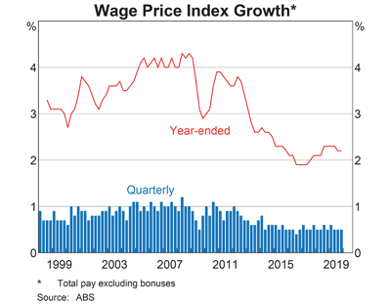

# **Source:** Chart Pack, Factors of Production and Labour Market, 4 March 2020, Reserve Bank of Australia.

Weak growth in earnings and social security payments is stunting consumer demand, which rose by just 1.2% through 2019. Households on lower incomes are either dis-saving or running down their savings to meet ongoing costs. These trends cannot continue. The household saving rate declined from 4.7% in December 2016 to 3.6% in December 2019 (Figure 2).[19]

Figure 2:

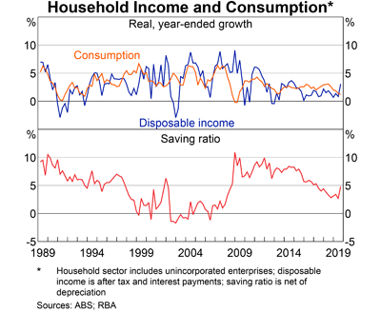

**Source:** Chart Pack, Household sector, 4 March 2020, Reserve Bank of Australia.

Under these conditions, minimum wage increases can make a real contribution to efforts to restore economic growth.

## Living standards

In 2019, the NMW rose by $8 per week (1.1%) over and above consumer price inflation.[20] From August 2016 to August 2018, it rose slightly against median full-time earnings, from 49.1% to 49.5%.[21]

ACOSS takes a long term view of minimum wage fixation and the needs of people living on low incomes. Since 1996, the minimum wage has declined from 61% to 49% of fulltime median weekly earnings (Figure 3). All things equal, this implies that low paid workers have fallen well behind growth in community living standards.

**Figure 3: Minimum wage as a % of fulltime median earnings**

**Source: ABS, Employee earnings and hours.  
Note: Full-time non-managerial median earnings for all jobs held by an employee.**

While minimum wages cannot target poverty as precisely as social security payments, they are mainly paid to the lowest 50% of people of working age. Research undertaken by the Commission found that 44% of minimum wage earners were in the lowest three deciles of household income for households where at least one member was employed.[22] In 2016, 38% of low paid adult workers (earning below two thirds of the hourly median wage) who were partnered were either the sole or primary earners in the household.[23]

The forthcoming ACOSS/UNSW report, ‘Poverty in Australia 2020’ includes estimates of poverty among people in households where wages were the main source of income, derived from the ABS 2018-19 survey of income and wealth. This research uses both the OECD measure of poverty (50% of median household income) and the European Union measure (60% of median household disposable income), and – importantly - takes housing costs into account.

We find that in 2017-18, there were 1,017,000 people living below the 50% of median income poverty line and 1,666,000 people living below the 60% of median income poverty line, in households where wages were the main source of income. This comprised 38% and 40% of all people in poverty, respectively (apart from other than those in self-employed households).[24]

This represents a significant increase in the number of people in these households living in poverty since 2013-14. In that year, 32% of people below the 50% of median income poverty line and 34% of those below the 60% of median income poverty line came from households whose main income was wages.[25]

A hypothetical comparison by the Commission of disposable incomes for families receiving the NMW with the 60% of median income poverty line in September 2019 found that single parents employed part time (half of fulltime hours), and single earner couples with or without children, had disposable incomes below that poverty line, unless they also received Newstart Allowance.[26]

The Commission’s research indicates that in 2018, 28.2% of low-paid employee households, almost twice the share of all employee households (14.7%), experienced financial stress.[27]

One likely reason for this is the rising cost of housing, which is a major part of the budgets of low paid households. The Commission’s research found that in 2016, 52% of low paid working households (those where the primary earner received less than two thirds of median hourly wages) were renting privately.[28]

In December 2019, the median rent for a two bedroom flat was $525 a week in Sydney and $440 a week in Melbourne.[29]

## Relationship between minimum wages and social security

Inadequate real growth in both minimum wages and working-age social security payments (allowances and family payments) is contributing to their decline relative to median and average wages over the last two decades (Figure 4).

**Figure 4: Historical comparison of Newstart Allowance with pensions and wages ($2018)**

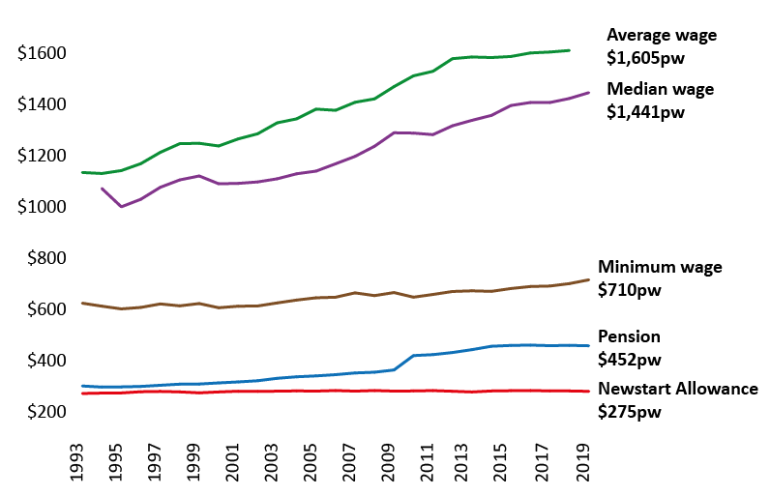

The social security system also affects the living standards of minimum wage-earning households through ‘in-work’ payments such as Family Tax Benefit. At the same time, minimum wages impact on social security payments for people of working age by making room for those payments to be set at adequate levels while maintaining reasonable rewards for paid work.

Since child endowment was introduced in the 1940s, family payments have supplemented minimum wages to help with the costs of raising children and reduce child poverty. In recent years, this social compact between workers, employers and governments has begun to break down.

In the Commission’s latest modelling of increases in disposable incomes of hypothetical families over the last year (receiving the NMW and no other private income), all except those relying on part-payment of Newstart Allowance recorded increases in disposable income after social security and tax of at least 2.2%. [30] Single parents and couples (with or without children) receiving part-payment of Newstart Allowance recorded increases in disposable income equal to or below the CPI increase of 1.6%. This reflects the inadequacy of the Newstart payment.

Taking a longer view, since 2009, budget cuts totalling over $12 billion have been made to payments for families with low incomes, including:

* The removal of indexation of Family Tax Benefit (Part A) for low-income families to wage movements in 2009, reducing payments since then by $13 per week for each younger child under 12 years and $17 per week for each older child;
* The freezing of the income test free areas for Family Tax Benefit from 2009 to 2020;
* The transfer of 80,000 sole parent families from Parenting Payment Single to the lower Newstart Allowance in 2013, at the time reducing payments for a sole parent with school-age children by at least $60 a week;
* The abolition of the ‘Schoolkids Bonus’ ($4.30 to $8.60 per child per week) for primary and secondary school-age children in 2016.
* The freezing of maximum rates of Family Tax Benefit (Part A) for low-income families in nominal terms from 2017 to July 2019.
* Removal of the Large Family Supplement for families with four or more children;
* Removal of Family Tax Benefit (part B) from couples whose youngest child is 13 years or over;
* The freezing of the income test free areas for Parenting Payment and Newstart Allowance for three years from 2017. [31]

The cumulative effect of these changes on the incomes of low-income families is substantial. For example, a sole parent with two preschool age children receiving the maximum rate of Parenting Payment Single has lost nearly $43 per week (around 6% of their disposable income). For a sole parent family with two children aged 8 to 15 years, the loss is about $136 per week (a cut in disposable income of nearly 19%).[32]

The experience of the last decade shows that governments cannot be consistently relied upon to supplement low pay for families with children, leaving them vulnerable to poverty in the absence of adequate increases in the NMW.

Minimum wages also impact on poverty indirectly, though their influence on social security settings. There is a consistent long term relationship between minimum wages and unemployment benefits. Between 1995 and 2010, unemployment payments for a single adult with no dependent children sat in a narrow band between 43-44% of the NMW (before tax). Newstart Allowance has since fallen to 38% of the NMW, suggesting there is considerable scope to increase Newstart without impacting on rewards for employment.[33]

The constancy of this relationship over the longer term is not surprising given official concerns (accurate or not) about the effect of income support payments on work incentives. This historical link between minimum wages and social security payments helps explain why higher minimum wages are associated in international comparisons with lower levels of child poverty, even though only a minority of poor households in most OECD countries benefit directly from minimum wages.[34]

Minimum wages also play an important role in reducing the gender pay gap, which is caused by a combination of unequal sharing of caring roles, the over-representation of women in relatively low paid caring occupations (including in the community services sector), and discrimination against women in hiring and promotions. In 2018, the gap between adult (non-managerial) hourly ordinary time earnings between men and women was $6.41 per week, or 15.2% of the average male rate. Minimum wage increases from 1995 to 2005 were estimated to reduce the gender pay gap by 1.2 percentage points.[35]

As the peak organisation in the non-government community services sector, ACOSS has a particular interest in employment issues in community services. The community sector’s capacity to provide quality services depends on the availability of suitably skilled employees, many of whom rely on the award system for their wages.

The vast majority of employees in the community services sector (82%) are women. Consistent with the treatment of caring work more broadly, their work is undervalued, despite being highly-skilled.

In 2018, 32% of employees in health care and social assistance were award-reliant (up from 17% in 2010), making this one of four major industries with a high share of award-reliant workers; the others being retail; accommodation and food services; and administrative and support services.[36]

We warmly welcomed increases in pay for community workers arising from the Commission’s equal remuneration decision in 2012, which are being phased in up to 2020.[37] Further increases are likely to be needed over time to improve the quality of community services by helping avert shortages of skilled workers. Regrettably, the Australian government’s financial support for community sector employers to meet these pay increases expires in 2021. ACOSS and the COSS Network are strongly advocating that this vital support be renewed.[38]

## Employment

Employment growth was solid through 2019, rising by 287,000 or 2.3% (a similar increase to that in 2018).[39] Yet, as indicated, wage growth and inflation remain low. The unemployment rate rose from 5.0% to 5.2% due to an increase in the participation rate (from 80.8% to 81.4% for people aged 20-64 years).[40]

The RBA has identified a significant change in the relationship between unemployment and inflation.[41] Similar changes in other wealthy nations have led economists to question whether further reductions in unemployment are constrained by the risk of a break-out in inflation (the NAIRU or structural unemployment constraint).[42]

The RBA recently revised its central estimate for the NAIRU from 5% to 4.5%, and it is likely in our view that unemployment could be reduced further than this without adverse economic consequences.[43] This brings one obvious benefit - unemployment has declined and can continue to fall with risking excessively high inflation - but it raises questions about the level of growth in general living standards that can be achieved in coming years.

## Recommendations

We recommend that the NMW be increased consistently and substantially to reduce the gap between the NMW and the median wage. While we do not recommend specific increases in minimum wages, the rest of our recommendations focus on how the needs of people on low pay can best be assessed, and the respective roles of wages and social security in sustaining a decent standard of living. Our starting point is that the NMW should be designed to at least provide a decent living standard, well above poverty levels, for a single adult; and that the tax-transfer system should meet the basic costs of raising children in a low income family.

The NMW should not be directly designed to cover the costs of children because that role is best performed by the social security system. In assessing the living standards of low paid workers and their families, the Commission should take account of both minimum wages and social security payments, especially Family Tax Benefits. Nevertheless it is vital that the NMW and family payments together are sufficient to prevent a family from falling into poverty.

The minimum wage itself should be set well above poverty levels, in keeping with Australian public policy tradition, and the desirability of maintaining an appropriate gap between maximum social security payments and minimum wages.

In addition to these measures, an appropriate benchmark for the adequacy of the NMW would be to compare it with the full-time median wage. A reasonable goal would be to restore its value to at least 60% of the full-time median wage.

We do not propose that minimum wages be tied to a single measure of income adequacy such as a poverty line or budget standard. Fair Work Australia needs the flexibility to take account of the other factors including the state of the economy, work incentives and employment. Nevertheless, without reference to benchmarks grounded in thorough independent research on living standards, the adequacy of minimum wages cannot be objectively assessed. ACOSS welcomes the Commission’s use of updated poverty lines, financial stress indicators and expenditure patterns of low paid workers in the Annual Wage Review Statistical Reports.

We recommend that:

* The Commission should increase real minimum wages substantially in order to significantly reduce the gap between them and median pay levels.
* Decisions on the level of minimum wages should be informed by benchmark estimates of the cost of attaining a ‘decent basic living standard’ for a single adult according to contemporary Australian standards.
* A reasonable benchmark for the adequacy of minimum wages in comparison with wages across the community would be 60% of the fulltime median wage.
* The combined effect of the minimum wage and family payments on the extent of poverty among families, including recent significant cuts in family payments, should also be expressly considered in setting minimum wages.
* The FWC should continue to commission research and hold consultations with stakeholders to develop and update a robust set of indicators of a minimum adequate living standard for people in low paid work. It should regularly assess the living standards of individuals and households receiving minimum wages against median household disposable incomes, poverty lines, budget standards and deprivation indicators, including financial stress indicators.
* Minimum wage rates for young people, apprentices and trainees, and people with disability under the Supported Wage System, should continue to be increased in line with the rise in the NMW.

1. Fair Work Commission (2018)*, Decision, Annual Wage Review 2017–18*.
2. Australian Bureau of Statistics (ABS), *Employee earnings and hours, Australia series* Cat no 6306.0
3. Davidson, P., Saunders, P., Bradbury, B. and Wong, M. (forthcoming)*, Poverty in Australia, 2020*. ACOSS/UNSW Poverty and Inequality Partnership Report No. 4, Sydney: ACOSS.
4. ACOSS & UNSW (2016), *Poverty in Australia,* Sydney*.*
5. ABS (2020), *National Accounts*, December quarter 2019.
6. ABS (2020), *Wage Price Index, Australia, September 2019*, ABS (2020), Consumer Price Index, December 2019.
7. RBA (2019), *Statistics - demand and income*.
8. <https://treasury.gov.au/speech/opening-statement-march-2020-senate-estimates>
9. ACOSS (2019), [*Budget Priorities Statement, 2020*](https://www.acoss.org.au/wp-content/uploads/2017/02/ACOSS_Budget-Priorities-Statement_2017-18-FINAL.pdf)*-21.*
10. Whiteford, P et al (2019), *It’s not just Newstart: Single parents are $271 per fortnight worse o*ff, The Conversation, December 3, 2018.
11. In the Commission’s modelling of changes in the disposable incomes of hypothetical families children relying on the NMW from 2013 to 2018, families with children (whether singles or couples) had smaller increases in household disposable income than those without children (Fair Work Commission (2019), *Statistical report—Annual Wage Review 2018–19*, Table 8.4). Federal Budget reductions in family payments and income support payments are likely to be a major reason for this.
12. Davidson, P., Saunders, P., Bradbury, B. and Wong, M. (2018)*, Poverty in Australia*. ACOSS/UNSW Poverty and Inequality Partnership Report No. 3, Sydney:ACOSS.
13. Productivity Commission (2015)*, Workplace Relations Framework, Productivity Commission Inquiry Report Volume 1*, page 201; Bishop J (2018), *The Effect of Minimum Wage Increases on Wages, Hours Worked and Job Loss,* RBA Bulletin September 2018.
14. Dube A (2019), Impacts of minimum wages: review of the international evidence, University of Massachusetts Amherst, report for the Low Pay Commission:London.
15. The RBA has revised downward its estimate of the non-accelerating inflation rate of unemployment (NAIRU) from 5% to around 4.5%. This reflects, among other factors, the high rate of underemployment, which sat at 8.5% of the labour force in January 2020 (ABS 2020, *Labour Force, Australia*, January 2020).
16. ABS (2020), *National Accounts*, December quarter 2019.
17. Lowe P (2019), *The Housing Market and the Economy*, Address to the AFR Business Summit

    Sydney, 6 March 2019
18. ABS, *Wage Price Index, Australia, Dec 2019*
19. RBA (2019), *Statistics - demand and income*.
20. Fair Work Commission (2019), op cit.
21. Fair Work Commission (2019), op cit; ABS, Employee Earnings and Hours, Australia, various, Catalogue No. 6306.0.
22. Jiminez and Rozenbes (2017), *Award reliant workers in the household income distribution.* Fair Work Commission.
23. Yuen, et al (2018), *ibid*.
24. Davidson, P., Saunders, P., Bradbury, B. and Wong, M. (forthcoming)*, Poverty in Australia, 2020*. ACOSS/UNSW Poverty and Inequality Partnership Report No. 4, Sydney: ACOSS. The data source is the ABS Income and wealth survey (2017-18).
25. ACOSS & UNSW (2016), *Poverty in Australia,* Sydney*.*
26. Fair Work Commission (2020), *Statistical report – annual wage review.*
27. Fair Work Commission (2020), *ibid. ‘Low-paid’* households refers to those in the bottom quintile of equivalised disposable household income for employee households.
28. Yuen, et al (2017), op cit.
29. Housing NSW (2019) *Rent and Sales Report, A*vailable:   
    <https://www.facs.nsw.gov.au/download?file=770233> ;   
    Department of Human Services Victoria (2018) *Rental Report, September quarter 2018* Available: <https://www.dhhs.vic.gov.au/sites/default/files/documents/201812/Rental%20Report%20September%202018.docx>
30. Fair Work Commission (2019), *Op.Cit; Table 8.4*.
31. Whiteford, P et al (2019), *It’s not just Newstart: Single parents are $271 per fortnight worse o*ff, The Conversation, December 3, 2018.
32. Whiteford, P et al (2019), *It’s not just Newstart: Single parents are $271 per fortnight worse o*ff, The Conversation, December 3, 2018.
33. Department of Human Services (2019) [*A Guide to Australian Government Payments*](https://www.humanservices.gov.au/sites/default/files/2017/12/co029-1801.pdf)  and [*History of National Increases*](http://workplaceinfo.com.au/payroll/wages-and-salaries/history-of-national-increase)
34. OECD 2017, <http://data.oecd.org/inequality/poverty-rate.htm> and <https://data.oecd.org/earnwage/wage-levels.htm>
35. Fair Work Commission (2019), *op cit*; Austen et al (2008), *Gender pay differentials in low paid employment,* *Women in social and economic research*, commissioned by the Australian Fair Pay Commission.
36. Fair Work Commission (2020) *Op. Cit.* 
37. Fair Work Australia, Equal Remuneration Case, Australian Municipal, Administrative, Clerical and Services Union and others, SOCIAL, COMMUNITY, HOME CARE AND DISABILITY SERVICES INDUSTRY AWARD 2010 [[MA000100](http://www.fwa.gov.au/documents/modern_awards/award/ma000100/default.htm)].
38. <https://www.acoss.org.au/wp-content/uploads/2019/04/ERO-payments-updated-July-2019.pdf>
39. ABS *Labour Force, Australia*.
40. Fair Work Commission (2020) *Op. Cit.*
41. Bishop & Cassidy (2017) *Insights into Low Wage Growth in Australia* RBA Bulletin March 2017;  
    Treasury (2017) [*Analysis of wage growth*](https://static.treasury.gov.au/uploads/sites/1/2017/11/p2017-t237966.pdf)
42. Blanchard (2017), Should We Reject the Natural Rate Hypothesis?, Peterson Institute for International Economics Working Paper 17:14
43. Cusbert (2017), Estimating the NAIRU and the Unemployment Gap, RBA Bulletin, June 2017;  
    Lowe P (2019), Testimony before the House of Representatives Standing Committee on Economics, Sydney, 22 February 2019.