Briefing note

The big squeeze: will the cure for high inflation turn out worse than the disease?

2 August 2024

# **Summary**

This brief tracks incomes, economic growth, unemployment, household spending and inflation in Australia to assess the impact of official interest rate increases since 2022.

We write at a time when the tide is turning on interest rate policies internationally – central banks in Europe, Canada and the United Kingdom have cut rates and a cut in the United States is expected soon. Yet recent discussion in Australia focussed on whether the RBA should *increase* rates to curb resurgent inflation. We believe this view is out of touch with economic conditions and lived experience in Australia today.

The logic and risks of the RBAs inflation-fighting strategy

While increases in official interest rates from COVID-emergency levels (0.1%) were inevitable, ACOSS has raised concerns about the pace and intensity of the fastest tightening of monetary policy in over 30 years, especially its impact on unemployment.

The purpose of these interest rate hikes was to bear down on inflation by slowing growth in demand for goods and services. The perennial risk with this approach is that the pain of high inflation is replaced by the pain of higher unemployment and falling incomes.

The RBA has a mandate to pursue full employment as well as low inflation

Just before the latest round of interest rate increases, Australia came closer to ‘full employment’ than in the last 50 years – the unemployment rate was below 4% for more than year.[1] This really matters for people on the lowest incomes:

* It means people who have been stuck in long-term unemployment (there are currently 550,000 people on unemployment payments long-term) finally have job opportunities, employers are more likely to offer more paid hours and better job security for people (mainly women) employed part-time, people can change jobs with confidence, wages can grow faster, and national prosperity is enhanced because fewer resources are wasted.

Are we still on the RBAs ‘narrow path’?

The RBA speaks of a ‘narrow path’ to reduce inflation without triggering a recession and high unemployment. The path is narrow because it’s rare for interest rate hikes of this scale and intensity NOT to trigger a serious economic downturn.

So far, we *appear* to have avoided the worst – the inflation rate has almost halved, the unemployment rate is just above 4% and a recession has apparently been avoided so far. However, increases in official interest rates take up to two years to flow through to important indicators like inflation, unemployment and growth in household incomes.

Scratch beneath the surface, and job opportunities and living standards have fallen sharply even without a recession

Over the two-year period from June 2022 to June 2024:

* Entry-level job vacancies have declined by almost one third (32%) and there are *an additional 100,000 people unemployed and 99,000 people underemployed* (unable to obtain the additional paid working hours they seek)
* Jobs growth has only been sustained by an extra 316,000 publicly funded jobs (with NDIS jobs likely to be prominent among them) while private sector employment has only grown by 6,000 per year.
* Over the last two years, while we just avoided a recession (if we define this as two quarters of zero or negative growth in GDP), when we adjust for the strong growth in population over this period the real value of goods and services produced *per person* has been falling. Economic growth per person – which is what ultimately determines living standards - has been extraordinarily weak.[2]
* People have felt the impact of that weak economic growth via *a decline in average incomes per person of 8% (around $5,000)* since June 2022, after adjusting for inflation. Importantly, the tax cuts, increases in Rent Assistance and energy rebates announced in the Budget will restore about one fifth of these income losses but the impact is too modest to trigger an upsurge in inflation (and Jobseeker Payment remains stuck at $55 a day).
* Contrary to the view that we ‘need’ higher unemployment to avoid a ‘price-wage spiral’, *average wages have fallen cumulatively by 2%* since June 2022 after adjusting for inflation. Fortunately, wages have started to grow above inflation again since mid-2023, backed by significant increases in minimum wages.
* As intended by the RBA, weak spending power has crimped our consumption of goods and services. But the fall in spending has been precipitous – *a 10% cumulative reduction in real spending per person* since June 2022. Retail sales have been especially weak, putting pressure on many small businesses.

Of course, these grim outcomes are not due to higher interest rates alone, but they point to the risk of an even sharper decline in job opportunities and incomes.

We’ve made good progress on inflation

* We have made good progress on inflation. Using the RBAs preferred ‘trimmed mean’ measure (which strips out the highest and lowest rises in prices), inflation almost halved from a peak of 6.8% a year at the end of 2022 to 3.9% in June 2024. Since December 2023 it has been falling more slowly, but it *has* continued to fall (from 4.2% to 3.9%).
* Along with higher interest rates and the easing of post-lockdown bottlenecks in the supply of goods and services, government action such as caps on gas prices and increases in Rent Assistance and childcare subsidies have contributed to these reductions in inflation (though more action is needed).

But increases in rents and higher mortgage interest costs will make housing more expensive for the foreseeable future

* Since June 2022, *the average annual increase in rents has grown from a modest 1.6% to a crushing 7.3%.* Above all else, it is *this* increase in the cost of one of life’s essentials that is putting pressure on people on the lowest incomes, driving many into homelessness.
* Higher interest rates and rising home values have lifted the proportion of overall household income devoted to home mortgage payments from 7.4% to 9.7%.[3]
* High interest rates are not contributing to efforts to reduce housing costs – on the contrary, they are one of the factors (along with the cost of building materials and zoning restrictions) constraining investment in home building. From June 2022 to June 2024, monthly home building approvals fell by 20% from 17,000 to 13,000 – well below the target set last year by Federal and State governments to commence building an average of 20,000 new homes a month.

A combination of weak income and jobs growth, higher interest rates and inflation has put more people under financial stress.

* Since September 2023, the *number of people having to live on the shockingly low ($55 a day) Jobseeker Payment and Youth Allowance rose by 82,000 (from 826,000 to 908,000).* Of those people, 60% (550,000) have received income support for over a year. Their employment prospects are diminishing.
* Since 2022, calls to the National Debt Helpline rose from 56,000 to 79,000 per year, after falling over the previous two years.

Conclusion – what should be done now?

There is no easy path to contain inflation without substantially reducing jobs and incomes and it is always hard to predict the impact of policies introduced now on the indicators that matter a year or so down the track. Yet the evidence presented here – especially the very weak growth in incomes and consumption and the decline in job opportunities - suggests that official interest rate increases went too far last year, shifting the balance of risks from an upsurge in inflation to an upsurge in unemployment and a recession.

ACOSS calls for:

* The RBA to start *reducing* official interest rates;
* Governments to act to curb inflation directly including by capping rent increases, further reducing out-of-pocket costs for essential services like childcare and health services, and investing to make homes energy efficient for people on low incomes;
* The Federal Government to lift Jobseeker and related payments to at least $80 a day and invest in a jobs and training offer for people unemployed long-term to improve their employment prospects.

### The 13 increases in ‘official interest rates’ from May 2022 were the fastest tightening of monetary policy in 30 years

The Bank’s ‘cash rate target’ rose from the exceptionally low level of 0.1% in COVID lockdowns to 4.35% in under 18 months from April 2022 to November 2023 (Figure 1).

#### Figure 1: RBA Cash Rate Target (%)

Source: RBA

### The RBAs fight against inflation comes at the expense of higher unemployment

The Bank has a ‘dual mandate’ to keep inflation within its target band of 2-3% and achieve full employment. When inflation is high and official interest rates are raised to contain it, these goals are in tension. The Bank speaks of a ‘narrow path’ of interest rate adjustments to curb inflation while avoiding a sharp rise in unemployment.[4]

Since the latest round of interest rate hikes commenced in mid-2022, job vacancies have fallen sharply (albeit from an historically high level), especially in entry-level jobs (ASCO skill levels 4 and 5) such as labourers and retail assistants, where vacancies have fallen by almost one third (32%).

The unemployment rate has risen cumulatively by around one-fifth (20%) and the underemployment rate has risen by 4%.[5] (Figure 2)

#### Figure 2: Cumulative changes in unemployment, underemployment & vacancies (%)

SOURCE: Australian Bureau of Statistics (2024), *Labour force, Australia;* Jobs and Skills Australia (2024)*, Internet Vacancy Index.*  
Note: ‘Cumulative change’ is the overall increase or reduction, expressed as a percentage of June 2022 values (not the change in unemployment and underemployment rates in percentage points).

Figure 3 shows the increase in the number of people unemployed and underemployed over the same period. There are 100,000 more people unemployed and 97,000 more people underemployed.

#### Figure 3: Cumulative increases in unemployment and underemployment (000s)

Source: Australian Bureau of Statistics (2024), *Labour force, Australia*

*Note: ‘*Cumulative change’ is the overall increase or reduction, expressed as a percentage of June 2022 values

Jobs growth has only been sustained by an extra 316,000 publicly funded jobs (for example in NDIS services) while annual private sector employment growth has *fallen* to just 6,000 (Figure 4).

#### Figure 4: Annual growth in employment by sector (000s)

Source: Australian Bureau of Statistics (2024), *Labour Account*, analysis by CBA Macrobond cited by Greg [Jericho](https://www.theguardian.com/business/grogonomics/article/2024/jul/18/australia-cost-of-living-crisis-interest-rates-inflation), Guardian Australia 18 July 2024.

### GDP per person and real household incomes have plummeted

Over the last two years, while we just avoided a recession (if we define this as two quarters of zero or negative growth in GDP), if we adjust for the strong growth in population over this period the real value of goods and services produced per person has fallen by $361 per quarter (from $22,870 in June 2022 to $22,509 in March 2024) - a reduction of $1,444 in annual terms (Figure 5). Real economic growth per person – which ultimately determines living standards - has been extraordinarily weak.

#### Figure 5: Quarterly GDP per capita

SOURCE: Australian Bureau of Statistics (2024), *Australian National Accounts: National Income, Expenditure and Product, March 2024*; Australian Bureau of Statistics (2024), *Population clock.*

Note: ‘Per capita’ includes children. Estimates are presented on a quarterly basis.

The impact of weak economic growth has been felt by people through a sharp decline in household spending power – average incomes per person have fallen by 8% ($4,941 per person per year) since June 2022, after adjusting for inflation (Figure 6):

* Tax cuts, increases in Rent Assistance and energy rebates announced in the Budget (shown in the column on the right side of the graph) are worth just under $1,000 per person in 2024-25. This will buoy living standards, but with modest impact (restoring around one fifth of income losses over the last two years). They are unlikely to trigger an upsurge in inflation.

#### Figure 6: Real household disposable income and average tax cut per person ($pa)

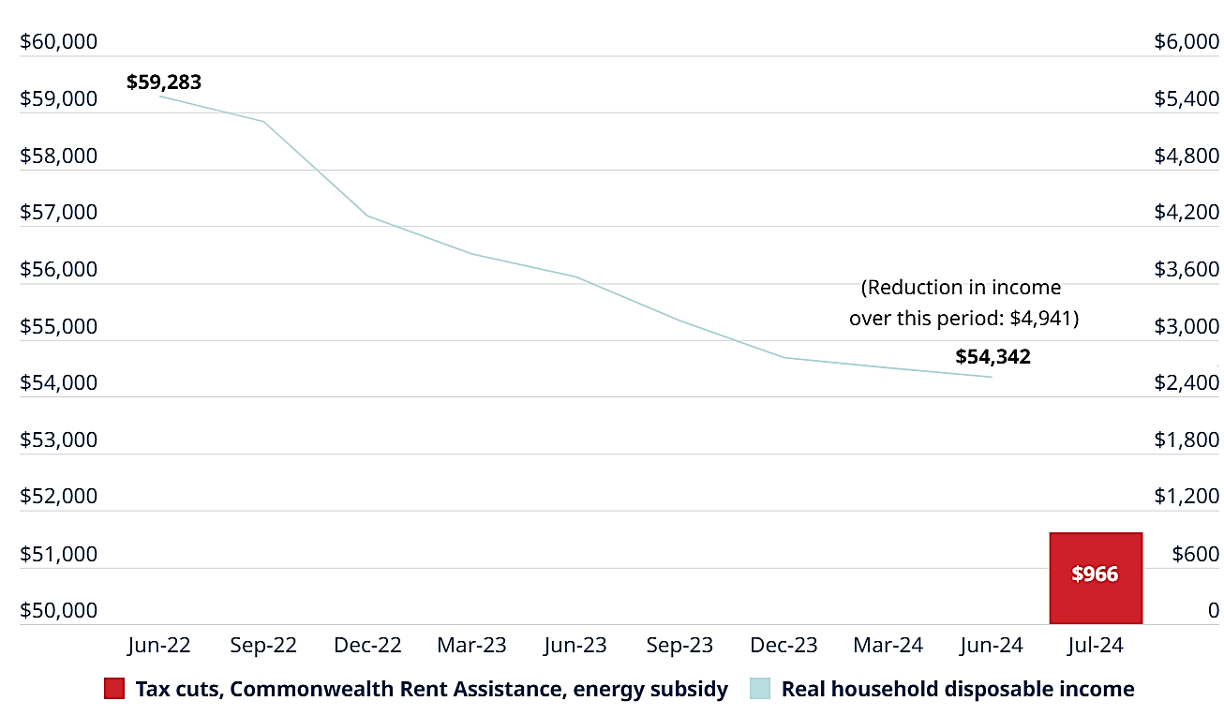

SOURCE: Australian Bureau of Statistics (2024), *Australian National Accounts: National Income, Expenditure and Product, March 2024*; Australian Bureau of Statistics (2024), *Population clock.*

Note: Estimates are expressed as annual, not quarterly values. ‘Real’ = after adjustment for inflation. Disposable income includes income support and any income tax paid. ‘Per person’ includes children.

The column on the right shows the average value of tax cuts, CRA & energy subsidy (per person) in 2024-25.

### Wages fell behind increases in inflation but have begun to catch up

Contrary to the view that we ‘need’ higher unemployment to avoid a ‘price-wage spiral’, real average wages have fallen cumulatively by 2% since June 2022. On a positive note, wages have started to grow modestly above inflation again since mid-2023, backed by significant increases in minimum wages (Figure 7).

#### Figure 7: Cumulative change in real wages (%)

Source: Australian Bureau of Statistics (2024), *Wage Price Index*; Australian Bureau of Statistics (2024), *Consumer Price Index Australia*.

Note: The Wage Price Index is a measure of pay increases in the same job (i.e. ignoring the effects of job changes and promotions), averaged across all employment.

We adjust for inflation using the CPI to derive estimates for growth in ‘real wages’.

‘Cumulative growth’ is all growth since June 2022, as a percentage of the June 2022 value.

### Real household spending has also fallen sharply

As intended by the RBA, weak spending power has crimped our consumption of goods and services. But the fall in spending has been precipitous – a 10% cumulative reduction in real spending per person since June 2022 (Figure 8). Retail sales have been especially weak, putting pressure on many small businesses.

#### Figure 8: Real household consumption per person – cumulative change (%)

Source: Australian Bureau of Statistics (2024), *Australian National Accounts: National Income, Expenditure and Product* (Tables 8 and 5); Australian Bureau of Statistics (2024), *Population clock*.

Note: ‘Cumulative change’ is the overall reduction, expressed as a percentage of June 2022 value.

### The inflation rate has almost halved and continues to fall, albeit more slowly

Based on the RBAs preferred ‘trimmed mean’ measure, inflation almost halved from a peak of 6.8% a year at the end of 2022 to 3.9% in June 2024 (Figure 9):

* Since December 2023 it has been falling more slowly, but it *has* continued to fall (from 4.2% to 3.9%).

#### Figure 9: Change in the CPI (trimmed mean - %)

Source: Australian Bureau of Statistics (2024), *Consumer Price Index, Australia*

Note: The ‘trimmed mean’ strips out the highest and lowest rises in prices.

The sum of the values for the last two quarters is doubled to ‘annualise’ them.

‘Year on year’ refers to the overall change from the same quarter in the previous year.

Quarterly = change in each quarter (noting RBA target range is expressed in annual terms).

### Increases in housing costs are a major contributor to remaining inflation and this is likely to persist

Since June 2022, the average annual increase in rents has risen from a modest 1.6% to a crushing 7.3% (Figure 10). Above all else, it is *this* increase in the cost of one of life’s essentials that is putting pressure on people on the lowest incomes, driving many into homelessness.

#### Figure 10: Annual increase in rents (%)

Source: Australian Bureau of Statistics (2024), *Consumer Price Index, Australia*

Higher interest rates and home values have lifted the proportion of overall household income devoted to home mortgage payments from 7.4% to 9.7% (Figure 11).[6]

**Figure 11: Housing loan repayments as a % of all household income**

Source: Reserve Bank of Australia statistical tables.

Note: Housing loan repayments (owner-occupied and investor) as a share of total household disposable income (including those without mortgages).

High interest rates are not contributing to efforts to reduce housing costs – on the contrary, they are one of the factors (along with the cost of building materials and zoning restrictions) constraining investment in home building.

Figure 12 shows that from June 2000 to June 2024, monthly home building approvals fell by 20% from 17,000 to 13,000. This is well below the target set last year by Federal and State governments to build an average of 20,000 new homes a month, commencing in July 2024.

#### Figure 12: Monthly home building approvals

Source: Australian Bureau of Statistics (2024), *Building approvals, Australia* (seasonally adjusted). Column on the right is the joint Governments’ target for new home building from July 2024.

### Higher unemployment and weak income growth, together with inflation, have put a growing number of people on low and modest incomes under financial stress

Since September 2023, the number of people having to live on the shockingly low ($55 a day) Jobseeker Payment and Youth Allowance rose by 82,000 (from 826,000 to 908,000). Of those people, 60% (550,000) have received income support for over a year (Figure 13). Their employment prospects are diminishing.

The number of people on unemployment payments has increased despite the transfer of many sole parents from Jobseeker Payment to Parenting Payment in September 2023, due to the 2023 Budget decision to restore Parenting Payment to parents whose youngest child is aged 8 to 14 years. This is the reason for the on-off reduction in people on unemployment payments in September 2023 shown in Figure 13.

#### Figure 13: Number of people receiving unemployment payments

Source: Department of Social Services (2024), *Time Series of Demographic Data of JobSeeker Payment (Previously Newstart Allowance) and Youth Allowance recipients, Jan 2012 – Jun 2024*.

Note: Legend refers to continuous duration of receipt of income support (over or under one year).

According to NAB bank’s Financial Stress Index, since mid-2022 the average financial stress level of people with below-average incomes rose consistently from around 48% to 56% (where a value of zero indicates no concern about finances and a value of 100 indicates extreme concern).

#### Figure 14: NAB Household Financial Stress Index

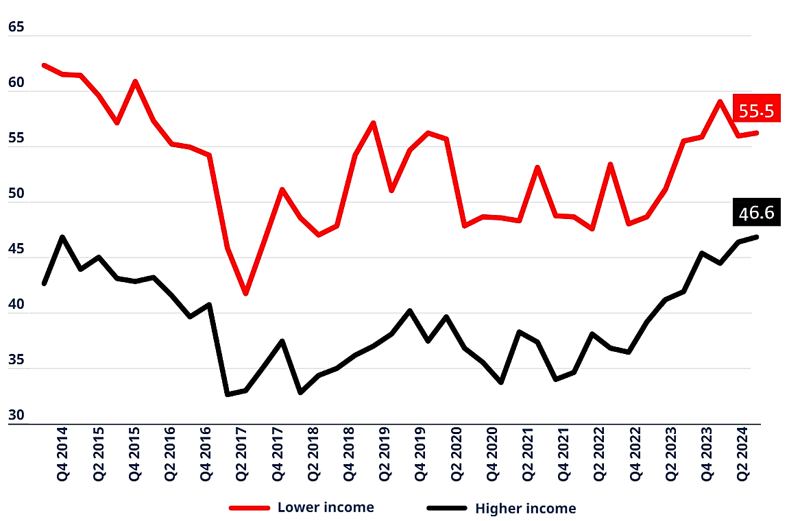

Source: NAB (2024), *NAB Australian Wellbeing Survey Q2-2024*.

Note: The index measures average stress levels for the two income groups (lower income = <75,000; higher income = >$75,000), where 0= not at all concerned; 100 = extremely concerned.   
The Index includes self-reported levels of concern regarding costs of healthcare, mortgage repayments, rent, credit cards, education, food & basic necessities, utility bills, insurances, holidays, entertainment, unexpected expenses, financing retirement, major household items and home improvements & maintenance.

Since 2022, calls to the National Debt Helpline rose from 56,000 to 79,000 per year, after falling over the previous two years (Figure 15).

#### Figure 15: Total calls to National Debt Helpline

Source: National Debt Hotline <https://ndh.org.au/about-national-debt-helpline/>

### Contact

Dr Peter Davidson, Principal Advisor

E: [peter@acoss.org.au](mailto:peter@acoss.org.au) , M: 0414139902

1. Broadly speaking, we have full employment when there is a job vacancy for each person unemployed and people can secure employment without having to search for too long.
2. By ‘real’ we mean after adjusting for inflation.
3. This includes households without home loans – clearly the proportion will be much higher for those actually making home loan repayments. Mortgage interest payments are not captured in the CPI.
4. Bullock M (2024), [Monetary Policy Decision](https://www.rba.gov.au/speeches/2024/mc-gov-2024-06-18.html) 18 June 2024.
5. That is, the unemployment rate is 20% higher (not 20 percentage points) than it was in June 2022.
6. Mortgage interest payments are not captured in the CPI.